**Date:** 18- Sep-2020

**What is meant by Transaction?**

It is process which all of the data modifications was successfully updated to the Database. The Process includes Committing Transactions and Rollback the process.

If a Transaction encounters errors, we can able to rollback the transactions

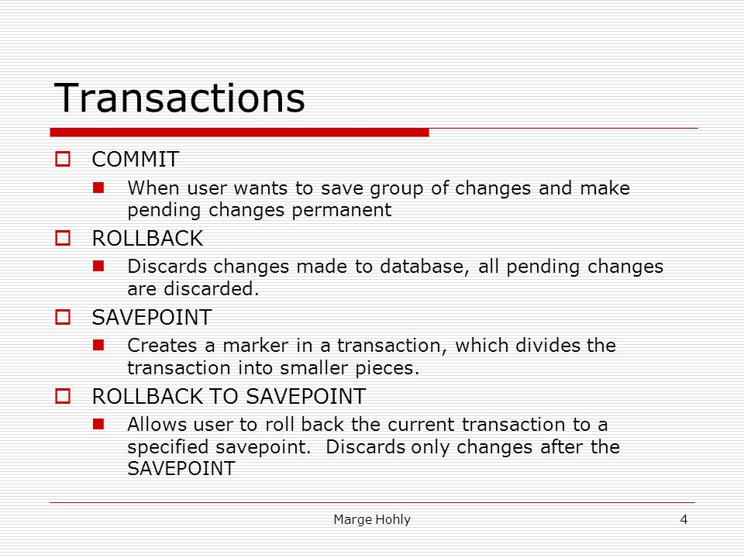

**Why We Need dbContext?**

It represents a session with the database which can be used to query and save instances of our entities to a database.

**DbContext** is a combination of unit of work and repository patterns.

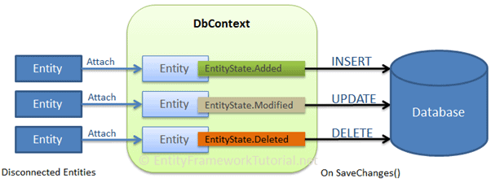

**Why we need Entity Framework?**

It is an ORM and ORM are aimed to increase the developer’s productivity by reducing the redundant task of persisting data used in the applications.

**Entity Framework** can generate the necessary database commands for reading or writing data in the database and execute them for you.

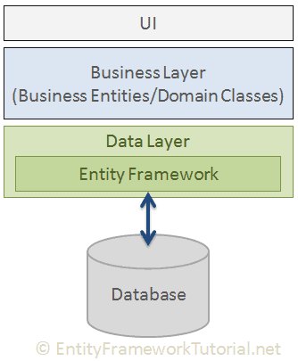

**What is the Purpose of ORM?**

An Object – Oriented relational mapper **(ORM)**  is a code library that automates the transfer of data in relational database tables into objects that are commonly used in application code.

**Why ORM?**

ORMs help to reduce the **Object-**Relational impedance mismatch. They allow you to store and retrieve full live **objects** from a relational database without doing a lot of parsing/Serialization self.

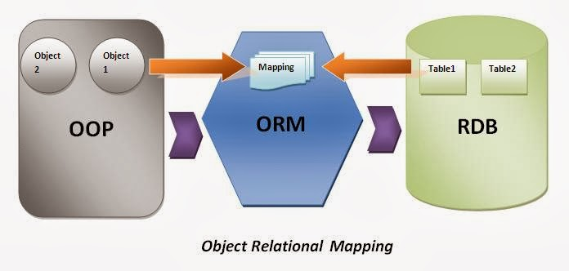

**What is meant by Relational Database?**

It organizes data into tables which can be linked – or related – based on data common to each. It stores data in Structured Format As Rows and Columns. The Term “**Relational”** Means tables are related to each other.

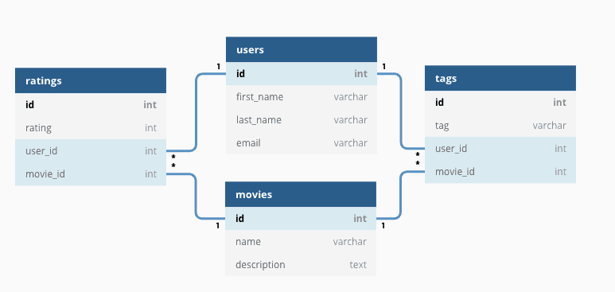

**Date:** 19- Sep-2020

**What is meant by Parsing?**

The Process of Turning some kind of data into another kind of data. It always turning a string, or binary data into a data structure inside your program. The Parser builds a Data Structure based on the tokens. This data structure can be used by a compiler, interpreter or translator to create an execute program or library. Parsing is a compiler that is used to break the data into smaller elements coming from lexical analysis phase. A Parser takes input in the form of sequence of tokens and produces output in the form of phase tree.

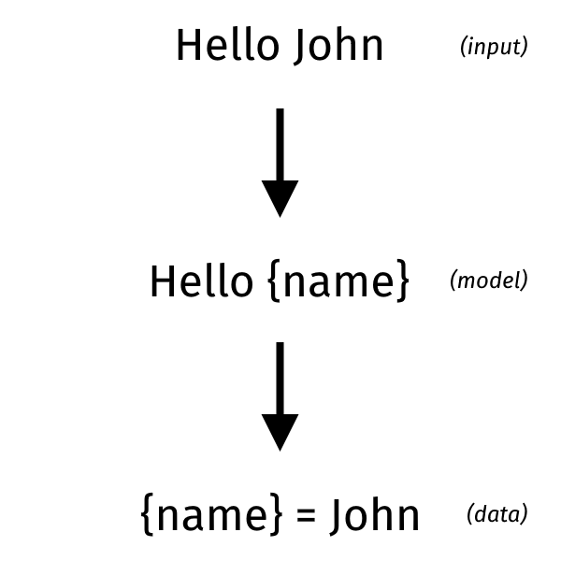

**What is meant by Serialization?**

The Process of converting an **object** into a **stream** **of** **bytes** to store the **object** or **transmit** it to **memory**, a **database**, or a **file**. Its main purpose is to **save** the **state** of an **object** in **order** to be able to recreate it when needed. The **reverse** **process** is called **deserialization**.

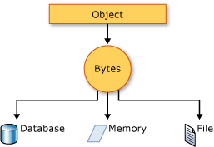

**What is meant by Binary Data?**

The data whose unit can take on only two possible states, traditionally labelled as 0 and 1 in accordance with the binary numeral system and Boolean Algebra.

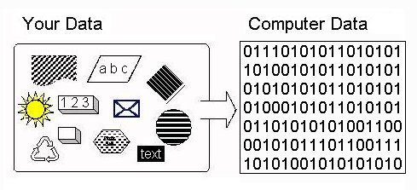

**Date:** 22- Sep-2020

**What is Isolation in SQL Server?**

**Isolation** level is nothing but locking the row while performing some task, so the other transaction can not access or will wait for the current transaction to finish the job.

**Date:** 23 - Sep-2020

**What is meant by Viewport (CSS)?**

The **viewport** is the user’s visible are of a web page. The **viewport** varies with the device, and will be smaller on a mobile phone on a computer screen. Before Tablets and mobile Phones, web pages were **designed** only for computer screens, and It was common for web pages to have a static design and a fixed size.

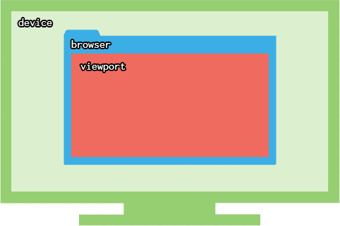

**Date:** 24 - Sep-2020

**What is meant by Queuing?**

The request was postponed by the rendering engine because its considered lower priority than critical resources (such as scripts/styles). This often happens with images.

The request was put on hold to wait for an unavailable TCP socket that’s about to free up.

The request was put on hold because the browser only allow six TCP connections per origin on HTTP 1.

Time spent making disk cache entries (typically very quick)

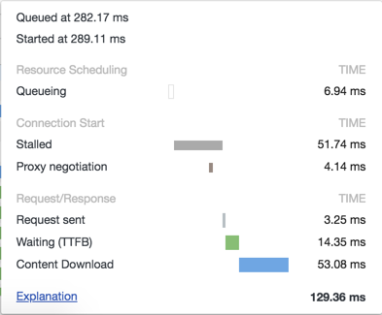

**What is meant by TCP Socket?**

A **Socket** is one endpoint of a two-way communication link between two programs running on the network. A **Socket** is bound to port number so that the **TCP** layer can identify the application that data is destined to be sent to. An endpoint is a combination of an IP address and a port number.

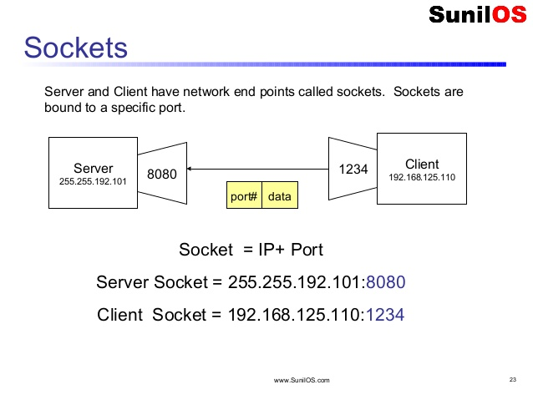

**What is meant by SSO?**

**Single sign**-on (**SSO)** is a property of **Identity** and **Access** **Management** (IAM) that enables users to securely authenticate with multiple applications and websites by logging in only once—with just one set of credentials (username and password).

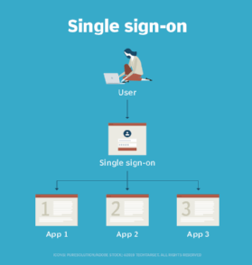

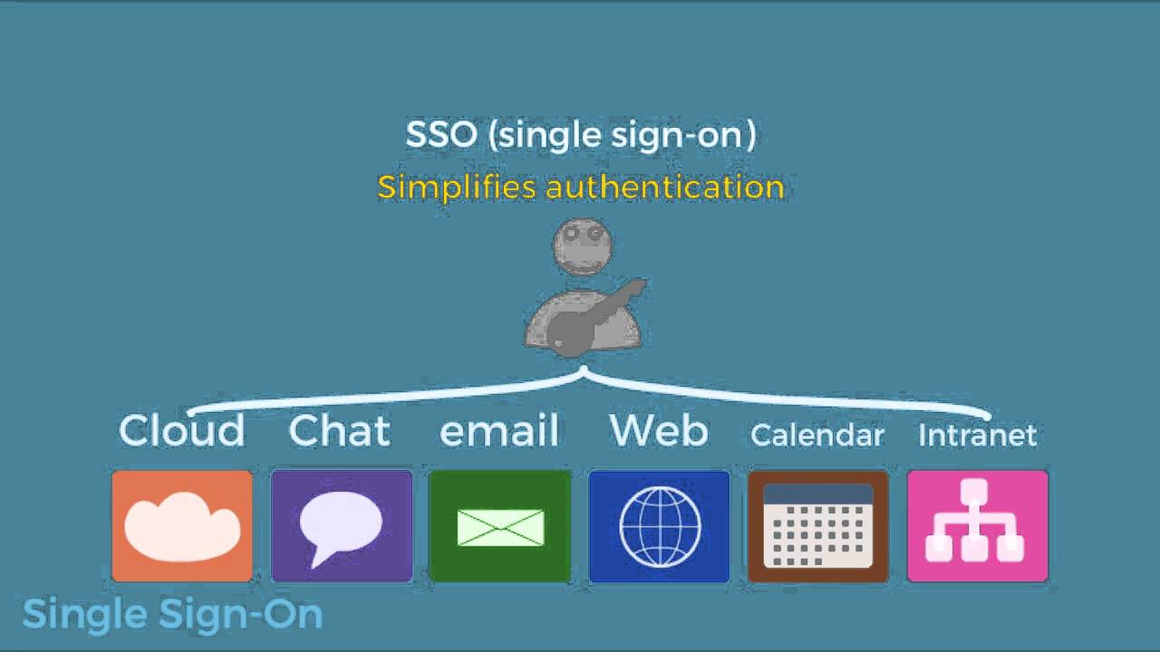

**What is meant by TCP?**

Transmission Control Protocol **(TCP) –** a connection-oriented communications protocol that facilitates the exchange of messages between computing devices in a network. It is the most common protocol in networks that use the Internet Protocol (IP); together they are sometimes referred to as **TCP/IP.**

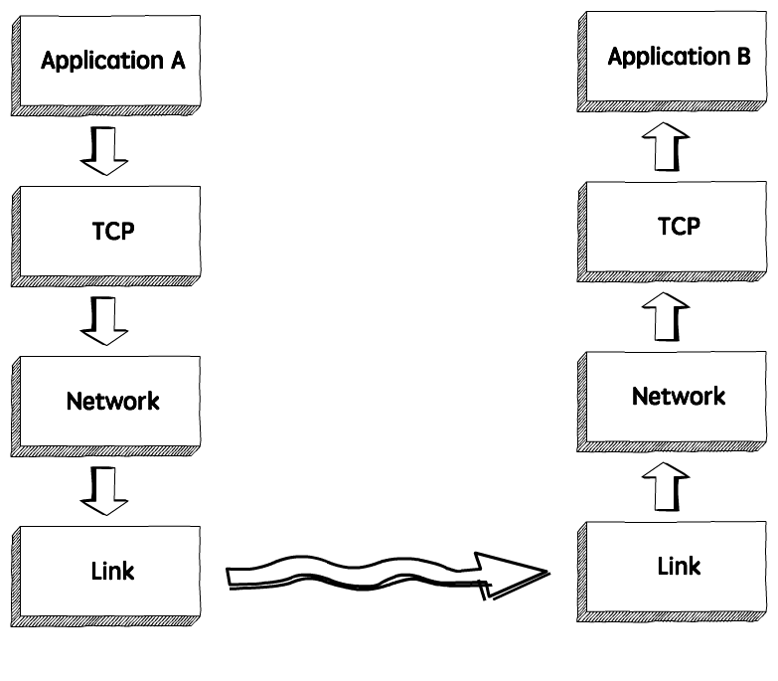

**What is meant by Internet Protocol?**

The **Internet Protocol (IP)** is a **protocol,** or a set of rules, for routing and addressing packets of data so that they can travel across networks and arrive at the correct destination. Data traversing the **Internet** is divided into smaller pieces, called **packets.**

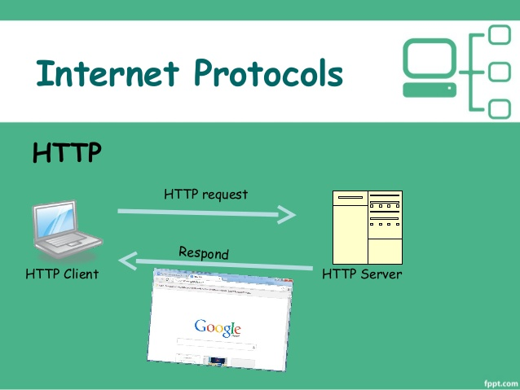

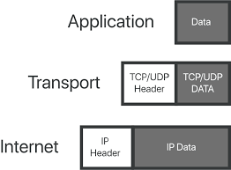

**Date:** 25 - Sep-2020

**What’s the difference between “Normal Reload”, “Hard Reload”, and “Empty Cache and Hard Reload” in Chrome?**

**Normal Reload:**

The same thing as pressing **F5.** This will use the cache but revalidate everything during page load, looking for **“304 Not Modified”** responses. If the browser can avoid re-downloading cached JavaScript files, images, text files, etc,. then it will.

**Hard Reload:**

Don’t use anything in the cache when making the request. (which is equal to **SHIFT + F5** No need to open Developer Console) Force the browser do re-download every JavaScript file, image, text, file, etc..

**Empty Cache and Hard Reload:**

Obviously, if the cache is empty then it will have to do a hard reload. This will again force the browser to re-download everything. However, if the page makes any after-the-fact downloads via JavaScript that weren’t part of page load, then these might still use the cache, which is where emptying the cache helps because it makes sure that even these won’t use cached Files.

**Note:** This feature is only available when the developer tools are open.

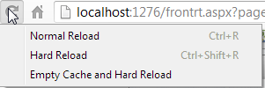

**What is meant by SSL?**

**SSL** Stands for secure sockets layer. Protocol for web browsers and servers that allows for the authentication, encryption and decryption of data sent over the Internet, .. Wildcard **SSL** certificates Type of certificate used to secure multiple subdomains.

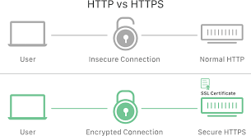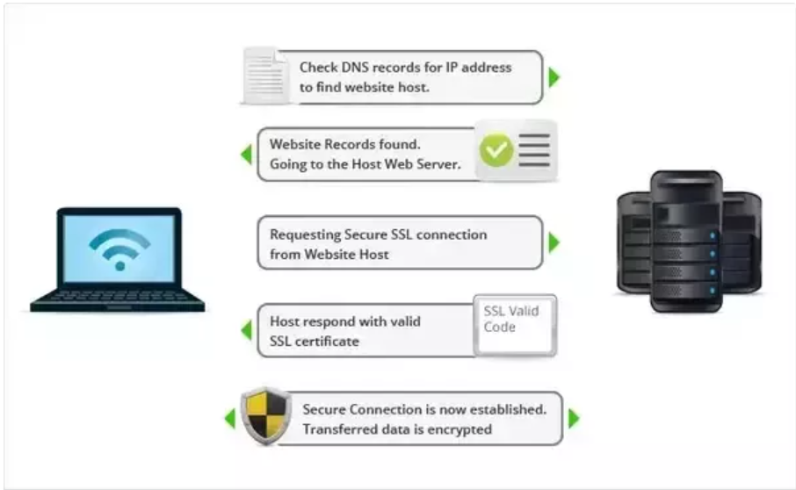

**What is meant by HashSet?**

**HashSet** extends Abstract Set and implements the Set Interface. It creates a collection that uses a hash table for storage. A hash table stores information by using a mechanism called hashing.. The hash code is then used as the index at which the data associated with the key is stored.

A **HashSet** holds a set of objects, but in a way that it allows you to easily and quicky determine whether an object is already in the set or not. It does so by internally managing an array and storing the object using an index which is calculated from the hashcode of the object.

**HashSet** is an unordered collection containing unique elements. It has the standard collection operations Add, Remove, Contains, but since it uses a hash-based implementation, these operations are O(1). (As Opposed to List for example, which is O(n) for Contains and Remove). **HashSet** also provides standard set operations such as *union, intersection,* and *symmetric difference.*

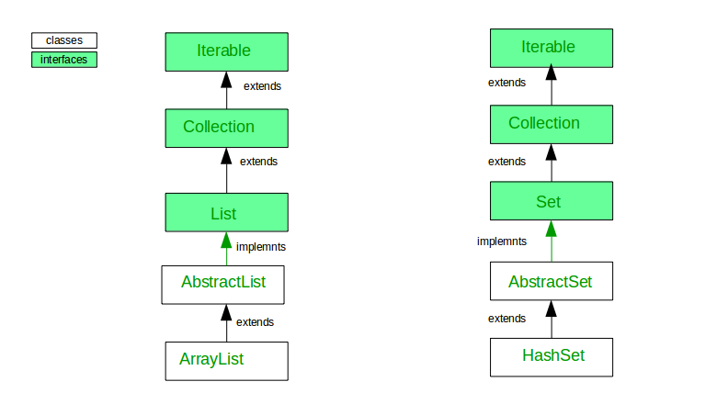

**Date:** 26 - Sep-2020

**What is meant by HTTP?**

**HTTP** is a protocol which allows the fetching of resources such as HTML Documents. It is the found of any data exchange on the Web and it is a client-server protocol, which **means** requests are initiated by the recipient, usually the Web browser.

HTTP Means **Hyper Text Transfer Protocol.**

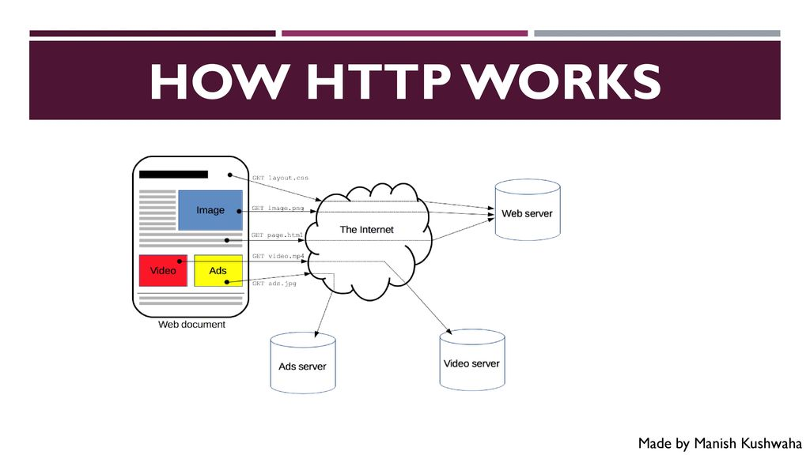

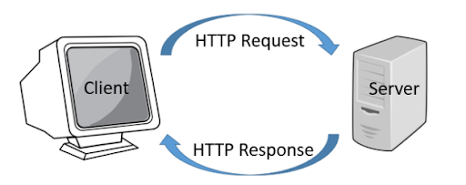

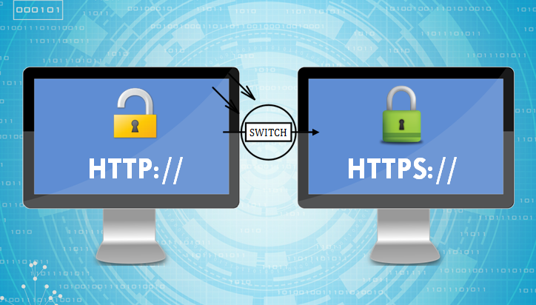

**What is meant by HTTPS?**

Hypertext Transfer Protocol Secure (**https)** is a combination of the Hypertext Transfer Protocol (HTTP) with the Secure Socket Layer **(SSL)**/ Transport Layer Security **(TLS)** protocol.

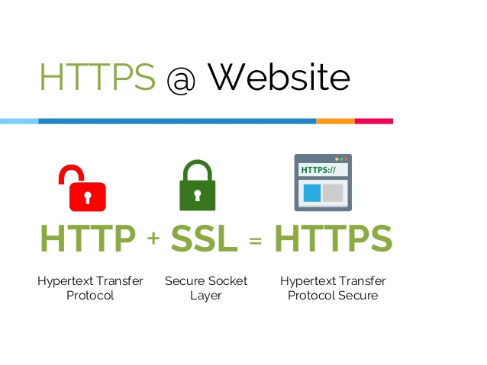

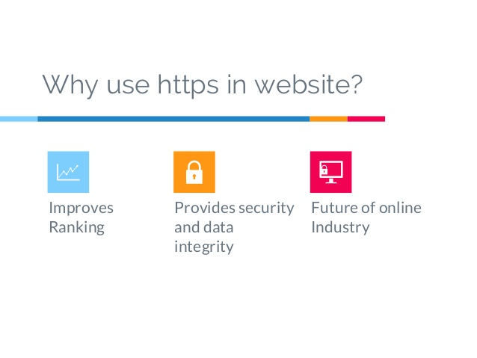

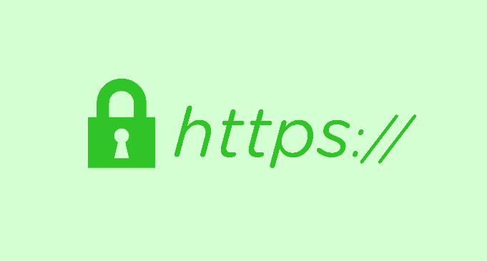

**What is Transport Layer Security (TLS)?**

TLS is a **security protocol** that provides privacy and data integrity for Internet Communications. Implementing TLS is a standard practice for building **Secure** web apps.

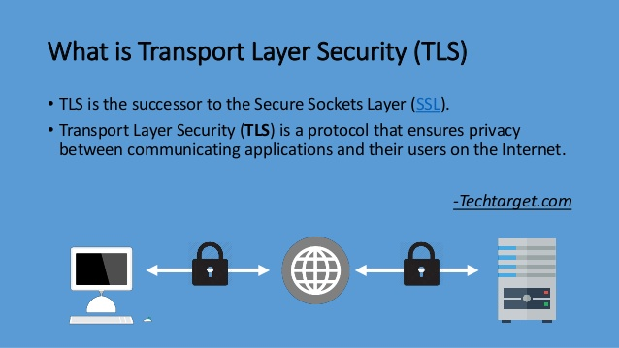

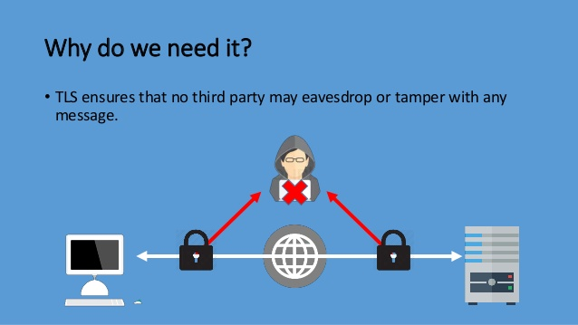

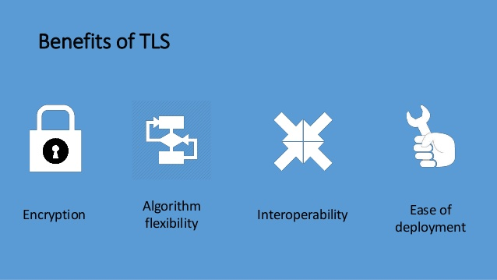

**Date:** 27 - Sep-2020

**What is a Session?**

A **Session** is a temporary and interactive information exchange between two or more communicating devices, or between a computer and user (see login **Session)** .. An Established Communication **Session** may involve more than one message in each direction.

A Session can be defined as a server-side storage of information that is desired to persist throughout the user’s interaction with the website or web applications.

Instead of storing large and constantly changing information via cookies in the user’s browser, only a unique identifier is stored on the client side (called a “session id”). This session id is passed to the web server every time the browser makes an HTTP request (ie a page link or AJAX Request). The web application pairs the session id with it’s internal database and retrieves the stored variables for use by the requested page.

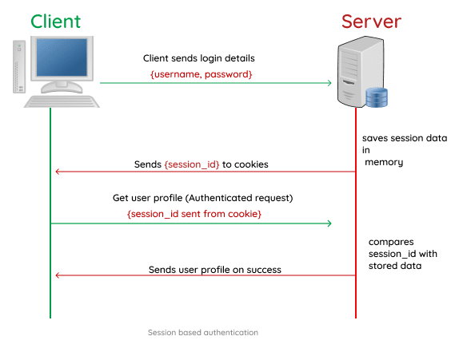

**Date:** 28 - Sep – 2020

**What is meant by Cookies?**

**Cookies** are text file with small pieces of data – like a username and password – that are used to identify your computer as you use a computer network. Specific **cookies** known as HTTP **cookies** are used to identify specific users and improve your web browsing experience.

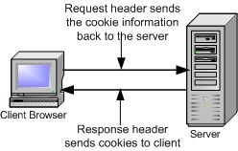

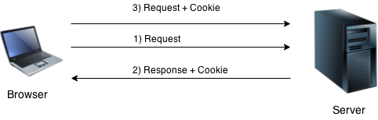

**What is the Difference between Cookies and Session?**

**Cookies and Sessions** are used to store information. **Cookies** are only stored on the client-side machine, while **sessions** get stored on the client as well as a server. A **session** creates a file **in a temporary directory** on the server where registered **session** variables and their values are stored.

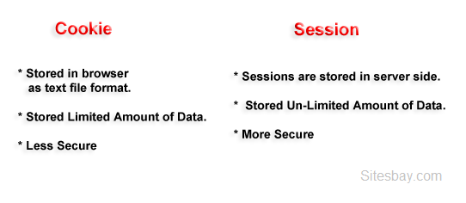

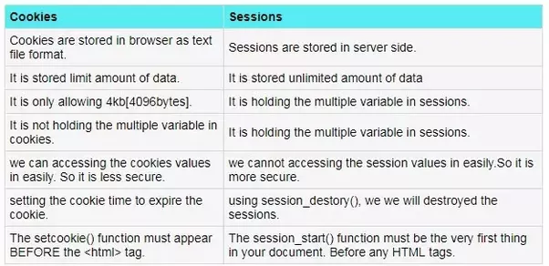

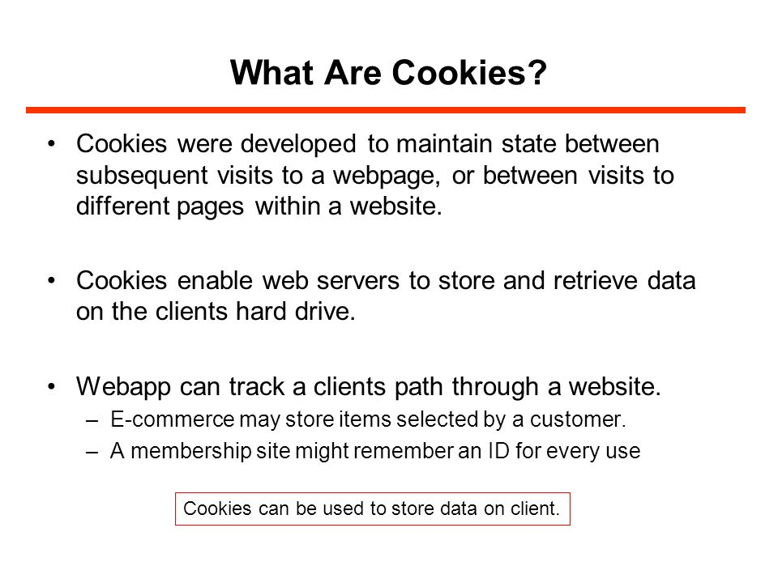

**What is meant by Local Storage ?**

**localStorage** is a type of web **storage** that allows **JavaScript** sites and apps to store and access data right in the browser with no expiry date. This **means** the data **stored** in the browser will persist after the browser window has been closed.

**What is the Difference between Cookies, Local Storage and Session Storage?**

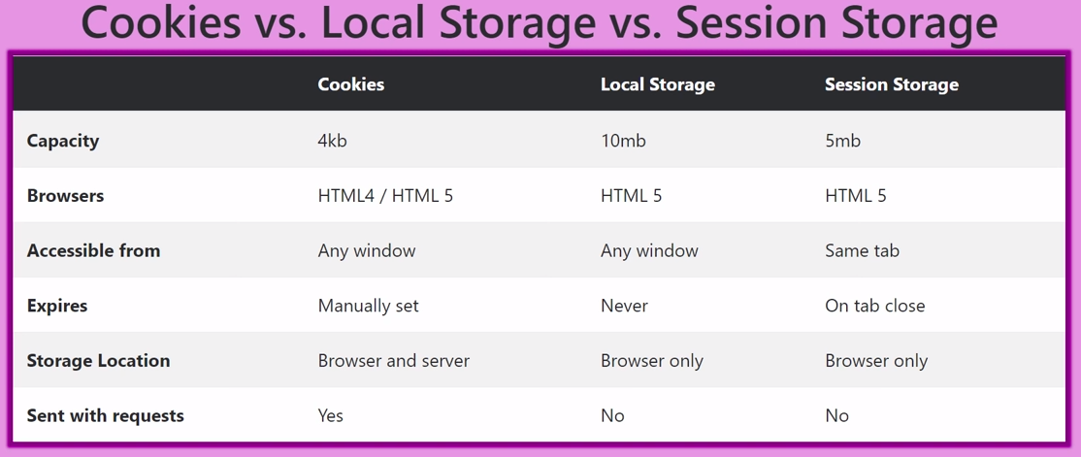

**Date:** 4 - Oct – 2020

**What is meant by .Net?**

**.net** is a top-level domain, also known as TLD. Derived from the word network, it was originally developed for companies involved in networking technology. Today, **.net** is one of the most popular domain names used by companies all over the world to launch their business online.

**NET** (pronounced dot **net**) is framework that provides a programming guidelines that can be used to develop a wide range of **applications**---- from web to mobile to Windows-based **applications. The .NET** framework can work with several programming languages such as C#, VB**.NET ,** C++ and F#

**Net** compromises both **frontend**  and **backend** languages. As for example, ASP**.NET** is used as **backend** and C# & VB**.NET** are used for **frontend** development.

**What is meant by .NET Framework?**

**NET Framework** is a software development **framework** for building and running applications on Windows. **.NET Framework** is a part of the **.NET** platform, a collection of technologies for building apps for Linux, macOS, Windows, iOS, Android, and more.

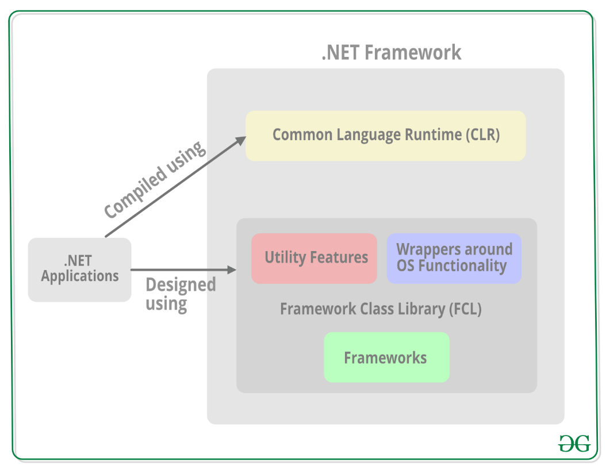

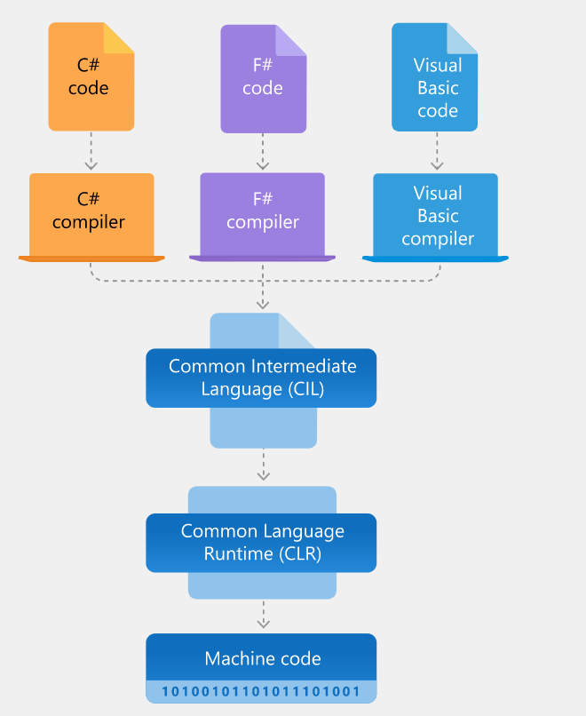

**List the Types of Apps and Services developed by NET Framework?**

**(Or)**

**What are all the Different Types of .NET Framework?**

* Console Apps
* Windows GUI apps (Windows Forms)
* Windows Presentation Foundation (WPF)
* ASP.NET Apps
* Windows Services
* Service-Oriented apps using Windows Communication Foundation (WCF)..
* Workflow-enabled apps using Windows Workflow Foundation.
* Others
  + Work with data using **ADO.NET**

**Date:** 7 - Oct – 2020

**What is meant by Incognito Window?**

**Incognito mode** is private browsing that doesn’t leave as many tracks. It can erase the temporary data that is captured by the PC or device you are using. Your browsing history didn’t save in this mode.

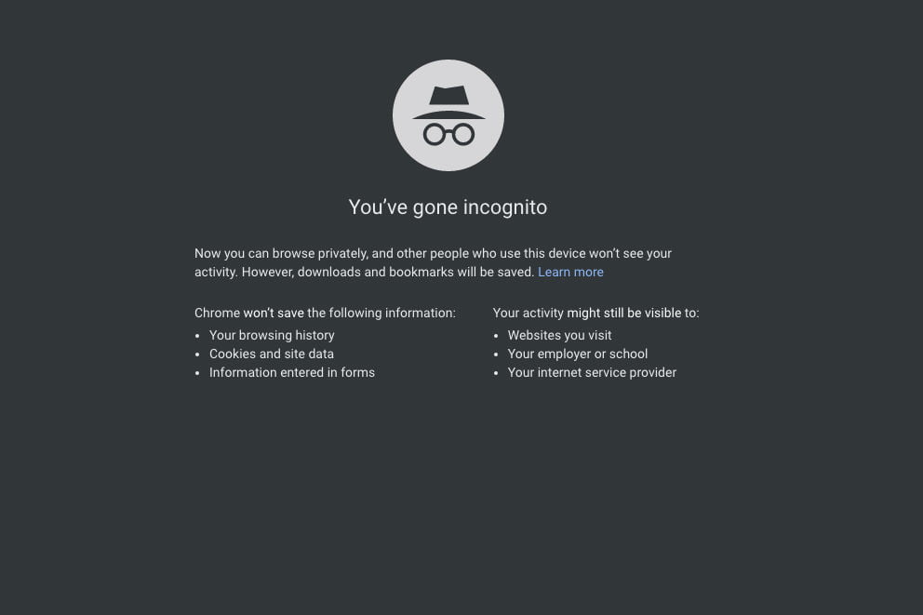

**Is Incognito is really safe?**

It explicitly states that your browsing activity might still be visible to websites you visit, your employer or school, and your internet service provider.

**What is the mean by Dynamic Link Library (DLL)?**

A **Dynamic-Link Library (DLL)** is a module that contains functions and data that can be used by another module (application or DLL). A DLL can define two kinds of functions: exported and internal. The exported functions are intended to be called by other modules, as well as within the DLL where they are defined.

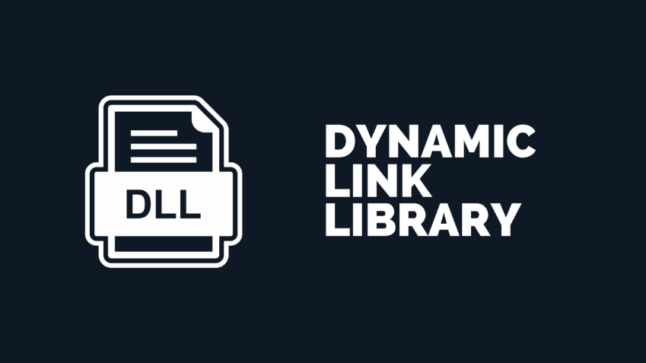

**What Language is DLL written in?**

DLL files use languages like **C or C++** although you will see **C++** more often. You can write your own DLLs run some code you need if you are willing to learn how to do it.

**How do I read a DLL file?**

**Microsoft Visual Studio**: Visual Studio is capable of **opening DLL file** and **viewing** and editing certain sections of it like textual resources, icons, messages, etc,..

**Microsoft Disassembler:** It is part of visual studio but it will allow you to **view DLL file** in great details. (**CIL Disassembler from Microsoft Store)**



**What is meant by DataView?**

A **DataView** enables you to create different views of the data stored in a DataTable, a capability that is often used in data-binding applications. Using a **DataView,** you can expose the data in a table with different sort orders, and you can filter the data by row state or based on a filter expression.

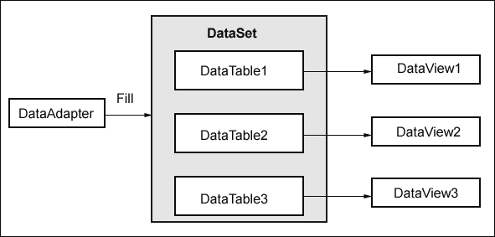

**Date:** 9 - Oct – 2020

**What is meant by Package?**

**Package (package** management system), in which individual files or resources are packed together as a **software** collection that provides certain functionality as a part of larger system. **Software** suite, which provides an organization collection of multiple **packages,** or a **package** consisting of multiple separate pieces.

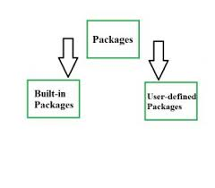

**Date:** 11 - Oct – 2020

**What is meant by Data Table?**

Any display of information in tabular form, with rows and/or columns renamed.(computing)

A table stored in, or derived from a database.

**Purpose:**

**Data tables** help you keep information organized. If you are collecting **data** from an experiment or scientific research, saving it in a **data table** will make it easier to look up later. **Data tables** can also help you make graphs and other charts based on your information.

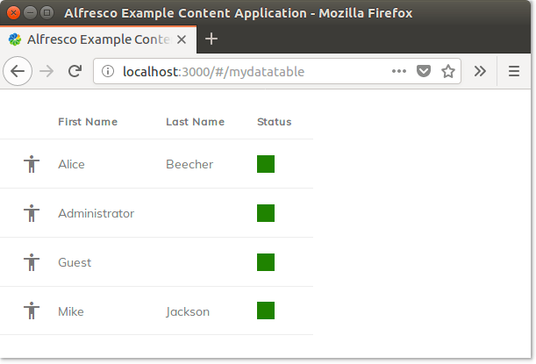

**Why Data Tables?**

Data tables are widely used during testing rules process when a user-defines all input test data in data tables and reuse them in several test tables of a project ( by referencing to the data table from test tables). As a result, different tests use the same data tables ( to define input parameter values, for example) avoiding duplicating data.

**Core Concepts of Data Table: (**[**https://datatables.net/manual/data/**](https://datatables.net/manual/data/)**)**

* Processing Mode
* Data Types
* Data Sources

**What is the Use of Data Table?**

A **DataSet** is made up of a collection of tables, relationships, and constraints. In ADO.NET, **DataTable** objects are used to represent the tables in a **DataSet.** A **DataTable** represents -one table of in-memory relational data; the data is local to the .NET-based application in which it resides, but can be populated from a data source such as Microsoft SQL Server using a **DataAdapter.**

**What is meant by Data Set?**

A **data-set** is a collection of **data.** In the case of tabular data, a data set corresponds to one or more **database tables,** where every **column** of a table represents a particular variable, and each **row** corresponds to a given record of the data set in question.

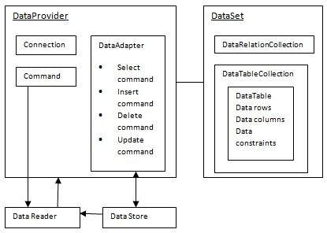

**Date:** 20 - Oct – 2020

**What is meant by CRDownload File?**

The **.crdownload** file extension indicates a file hasn’t finished downloading yet. Other web browsers may store-in-progress downloads in a different folder and move them to your downloads folder when they’re finished, but Chrome just stores the incomplete file in your Downloads Folder.

